**Continuous Integration and Continuous Deployment (CICD) from Git hub to AWS Lambda with Code Build (To Automatically update Lambda Function code)**

1. **Create a Lambda Function with Python 3.8 runtime**

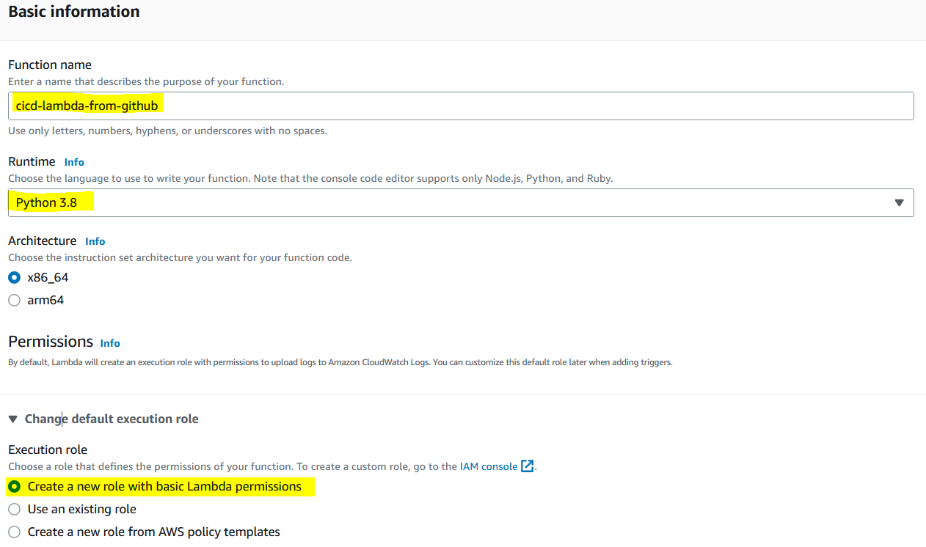

Then create function

1. **Clone the Git hub repository to work on it**

<https://github.com/kohlidevops/cicd-from-github-to-lambda/tree/main>

1. **To update the lambda function name in Git hub repository**

Open the buildspec.yml to update the lambda function name like below

1. **Create a Code Build in AWS**

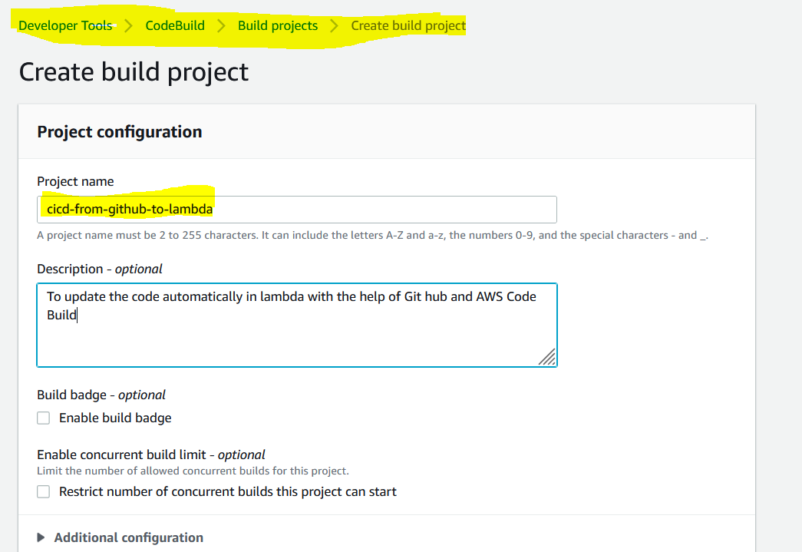

Source provide should be Git hub

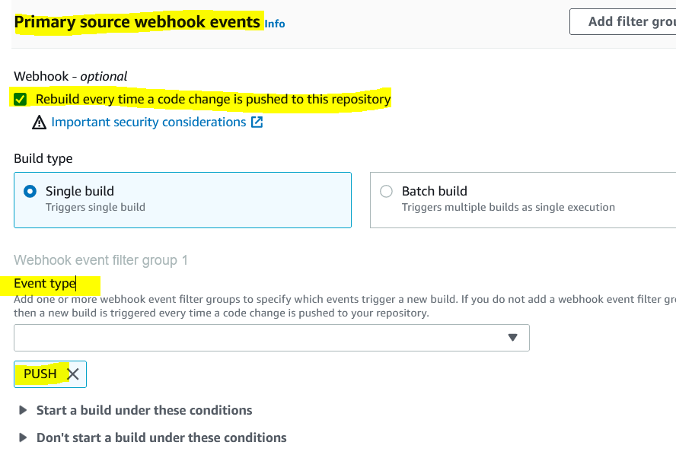

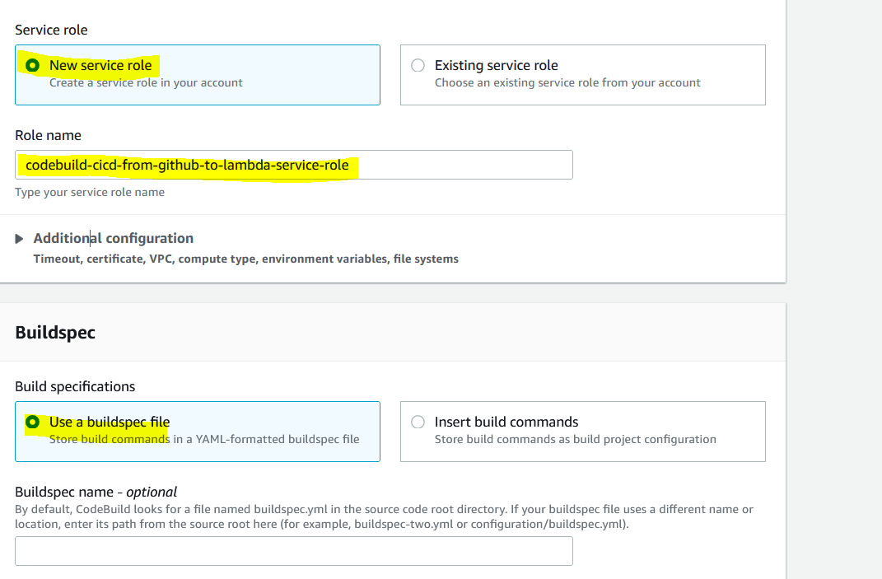

Then create build project

1. **To update the Code build service role with below iam policy**

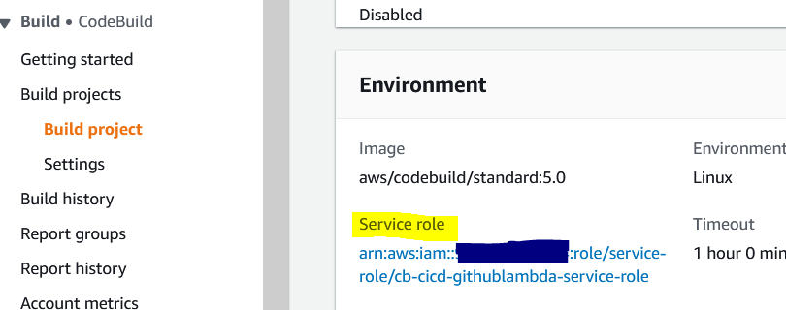

<https://github.com/kohlidevops/cicd-from-github-to-lambda/blob/main/iam-policy.json>

then update the lambda arn inside the policy – next – save changes

1. **To run the code build automatically**

Before run the code – lambda code

Do some changes in lambda_function.py file

Once changes occurred, the build is triggered, and you can see the phase details

The lambda code is updated after build project has been completed

1. **To test the Lambda function code**

You can see the log output

Latest build is succeeded

